6 September 2011

PPICS Data from 2009 - 2010*

Reports
Grantee-Level Programming Comparison
(APR Year 2010)

Bundle Profile
Bundle: Complete BIE
State: Bureau of Indian Affairs
Number of Sites: 63
Grade Levels served by this bundle: Other

Partner Information
Summary of Partner Information
Partner Information | N/Percent
Number of community partners | 226
Percent of partners receiving a subcontract | 29%

Operations
Of this bundle's 63 centers, 63 centers completed the operation section for APR Year 2010.

*at printing data in PPICS for 2010-11 was incomplete so the last year reported is used

Center | Summer |  |  | School Year
 | Hours Per Week | Days Per Week | Weeks Provided | Hours Per Week | Days Per Week | Weeks Provided
Alamo Navajo Community School | 44 | 5 | 10 | 6 | 5 | 42
American Horse School | -- | -- | -- | 12 | 4 | 32
Baca/Dlo ay azhi Community School | 24 | 4 | 4 | -- | -- | --
Beatrice Rafferty Elementary School | 20 | 5 | 4 | 10 | 4 | 26
Bogue Chitto Elementary School | 40 | 5 | 5 | -- | -- | --
Chemawa Indian School | -- | -- | -- | 71 | 7 | 36
Chief Leschi School | 16 | 4 | 3 | 19 | 4 | 34
Chinle Boarding School | 32 | 4 | 2 | 16 | 4 | 33
Choctaw Central Middle School | 40 | 5 | 5 | -- | -- | --
Cibecue Community School | 30 | 5 | 4 | 8 | 4 | 31
Conehatta Elementary School | 40 | 5 | 4 | -- | -- | --
Cottonwood Day School | 28 | 5 | 3 | -- | -- | --
Dibe Yazhi Habitiin Olta', Inc | -- | -- | -- | 6 | 4 | 29
Dzilth-Na-O-Dith-Hle Community Grant School | 30 | 3 | 3 | -- | -- | --
Flagstaff Dorm 21st Century After - School Program | -- | -- | -- | 20 | 5 | 30
Hannahville Youth Center | 79 | 7 | 14 | 52 | 7 | 38
Hunters Point Boarding School | -- | -- | -- | 9 | 3 | 30
Indian Island Elementary School | 25 | 5 | 3 | 12 | 5 | 30
Indian Township Elementary School | 30 | 5 | 3 | 6 | 3 | 26
Isleta Elementary School | 6 | 4 | 4 | 8 | 3 | 18
Jeehdeez'a Academy, Inc. | 16 | 4 | 4 | 12 | 4 | 8
Kayenta Community School | -- | -- | -- | 7 | 3 | 32
Keam's Canyon Elementary School | -- | -- | -- | 4 | 5 | 38
Kin Dah Lichi'i Olta, Inc. | -- | -- | -- | 8 | 4 | 25
Lac Courte Oreilles Ojibwe School | 32 | 4 | 6 | 8 | 4 | 33
Laguna Elementary School | 20 | 5 | 4 | 8 | 4 | 30
Little Wound Elementary School Wolakota K - 5th | 6 | 4 | 4 | 6 | 4 | 36
Loneman School | 10 | 4 | 5 | 5 | 5 | 43
Lukachukai Community School | 34 | 5 | 4 | 13 | 5 | 31
Many Farms High School 21st CCLC | 37 | 5 | 4 | 12 | 4 | 28
Meskwaki Settlement School | 27 | 5 | 4 | 8 | 4 | 32
Meskwaki Settlement School | 25 | 5 | 4 | 8 | 4 | 32
nazlini community school campus | 6 | 5 | 4 | 2 | 4 | 19
Northern Cheyenne Tribal School | 20 | 7 | 10 | 20 | 7 | 42
Ojibwa Indian School | 20 | 5 | 4 | 8 | 4 | 25
Pearl River Elementary School | 40 | 5 | 5 | -- | -- | --
Pierre Indian Learning Center | 168 | 7 | 6 | -- | -- | --
Pine Ridge school | 5 | 5 | 6 | 10 | 4 | 31
Pyramid Lake JR/SR High School 21st Century Community Learning Center | 20 | 4 | 6 | 8 | 4 | 35
Red Water Elementary School | 40 | 5 | 5 | -- | -- | --
Riverside Indian School Program | 7 | 5 | 8 | 10 | 6 | 27
Salt River Elementary School | 24 | 4 | 4 | 8 | 4 | 29
San Felipe Pueblo Elementary School | 8 | 4 | 8 | 3 | 4 | 10
San Ildefonso Day School 21st Century After-School Program | 20 | 5 | 4 | 14 | 5 | 34
San Simon School | 8 | 5 | 4 | 2 | 4 | 30
Santa Fe Indian School | 45 | 5 | 4 | 24 | 4 | 32
Santa Rosa Boarding School | 40 | 5 | 4 | 8 | 4 | 25
Seba Dalkai Boarding School | -- | -- | -- | 23 | 4 | 37
Shead High School | -- | -- | -- | 11 | 5 | 30
Shonto Preparatory School | 28 | 4 | 5 | 16 | 4 | 32
Shoshone-Bannock Jr./Sr. High School | 12 | 4 | 12 | 8 | 4 | 32
Sky City Community School | 10 | 4 | 5 | 19 | 5 | 33
St.Stephen's Indian School | -- | -- | -- | 11 | 4 | 35
Standing Pine Elementary School | 40 | 5 | 5 | -- | -- | --
Takini School | 6 | 3 | 2 | 7 | 2 | 18
Taos Day School 21st Century Out-of-School-Time Programs | 50 | 5 | 7 | 20 | 6 | 37
Theodore Jamerson | 24 | 4 | 6 | 16 | 4 | 26
Tiospaye Topa School | 5 | 4 | 3 | 8 | 3 | 15
Tohaali Community School | 40 | 5 | 4 | 8 | 4 | 38
Tohono O' Odham HIgh School20 | 30 | 5 | 4 | -- | -- | --
T'siya Day School | 28 | 4 | 4 | 12 | 4 | 10
Tuba City Boarding School | -- | -- | -- | 15 | 4 | 36
Tucker Elementary School | 40 | 5 | 5 | -- | -- | --

Staffing
Of this bundle's 63 centers, 63 centers completed the staffing section for APR Year 2010.
Total Staff for the School Year: 1081 | Total Staff for the Summer: 763
Total paid staff: 899 | Total paid staff: 642
- 52% school day teachers  - 24% other school day staff  - 24% other | - 49% school day teachers  - 23% other school day staff  - 28% other
Total Volunteer staff: 182 | Total Volunteer staff: 121
- 37% students  - 16% parents  - 47% other | - 24% students  - 34% parents  - 42% other
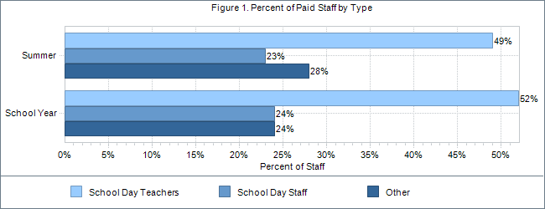

Attendance
Of this bundle's 63 centers, 63 centers completed the attendance section for APR Year 2010.
Number and percent of students attending:
- 10272 students served during the 2009/2010 school year
- 4803 students (47%) attended fewer than 30 days
- 5469 students (53%) attended 30 or more days and are regular attendees
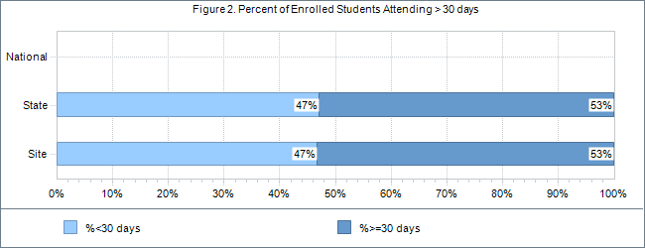

Individual Activities
Of this Bundle's 63 centers, 63 centers completed the individual activities section for APR Year 2010.
Percent of activity hours by activity category (Summer):
- Academic Enrichment: 43%
- Tutoring: 11%
- Homework Help: 0%
- Recreation: 18%
- Other: 28%
The majority of the academic enrichment and tutoring performed in the programs of the BIE are general in nature with a shot-gun approach to academic intervention. Individualized academic intervention was only utilized by 2 locations with consistency. The areas chosen as academic focal areas were often chosen through data however.
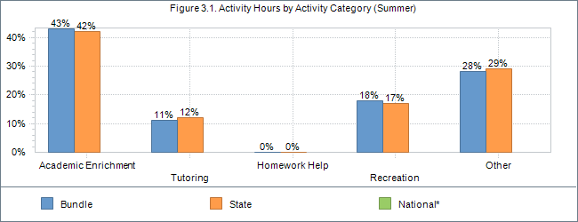*Note. National figures are based on individual activity data only (not all states collect individual activity data).

Percent of activity hours by activity category (School Year):
- Academic Enrichment: 32%
- Tutoring: 25%
- Homework Help: 15%
- Recreation: 9%
- Other: 19%
Many of the BIE programs were slanted academically offering both academic intervention generally and enrichment activities that were heavily academic.
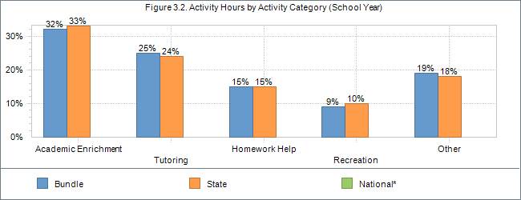
Percent of activity hours targeting a given core subject (Summer):
- Reading: 49%
- Math: 44%
- Science: 24%
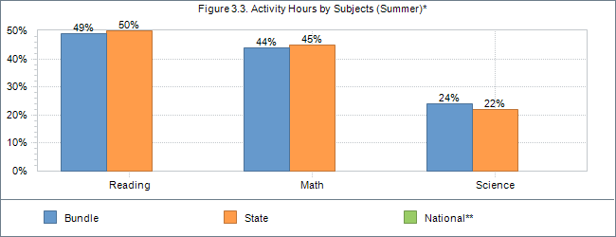*Note. A single activity can target multiple subject; percentages do not sum to 100%.
**Note. National figures are based on individual activity data only (not all states collect individual activity data).
Percent of activity hours targeting a given core subject (School Year):
- Reading: 67%
- Math: 55%
- Science: 33%
While reading has a stronger emphasis than does math in this report, the need based on standardized scores would be more reflective of even a greater reading emphasis.
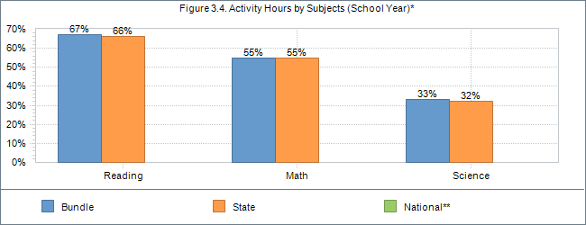*Note. A single activity can target multiple subject; percentages do not sum to 100%.
**Note. National figures are based on individual activity data only (not all states collect individual activity data).
Percent of activity hours targeting another subject (Summer):
- Arts and Music: 20%
- Entrepreneurial: 3%
- Technology: 18%
- Cultural: 26%
- Health: 25%
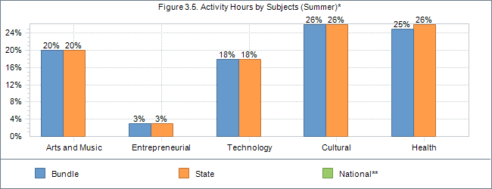*Note. A single activity can target multiple subject; percentages do not sum to 100%.
**Note. National figures are based on individual activity data only (not all states collect individual activity data).
Percent of activity hours targeting another subject (School Year):
- Arts and Music: 26%
- Entrepreneurial: 13%
- Technology: 27%
- Cultural: 32%
- Health: 33%
Activity hours are reflective of a balanced program concerning areas other than core academics however the missing statistics of frequency and duration would demonstrate that there is not programmatic balance of academics and enrichment as desired by the BIE. The relatively low number of students attending as RPP is also a demonstration of this with just over half attending more than 30 days and a much lower rate attending more than 45 days.
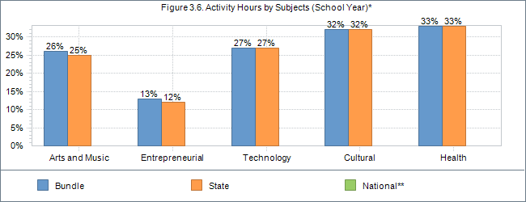*Note. A single activity can target multiple subject; percentages do not sum to 100%.
**Note. National figures are based on individual activity data only (not all states collect individual activity data).
Grades
Of this bundle's 63 centers, 63 centers completed the grades section for APR Year 2010.
Percent of regular attendees demonstrating improved grades:
- Reading/Language arts:
  - 30 to 59 days: 33%
  - 60 to 89 days: 53%
  - 90+ days: 42%
- Mathematics:
  - 30 to 59 days: 36%
  - 60 to 89 days: 48%
  - 90+ days: 42%
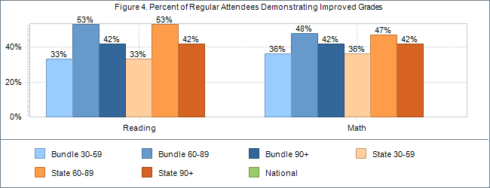

Achievement
Of this bundle's 63 centers, 63 centers completed the achievement section for APR Year 2010.
Percent of regular attendees who were below proficiency in the previous year but attained proficiency in the current year:
- Reading/Language arts:
  - 30 to 59 days: 26%
  - 60 to 89 days: 14%
  - 90+ days: 24%
- Mathematics:
  - 30 to 59 days: 22%
  - 60 to 89 days: 18%
  - 90+ days: 19%
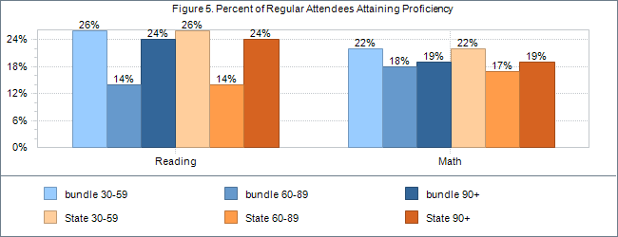

Teacher Perception of Improvement
Of this Bundle's 63 centers, 63 centers completed the teacher survey section for APR Year 2010.
Number of students attending 30 or more days in the program: 5469
Number of students for which a teacher survey was completed: 3656
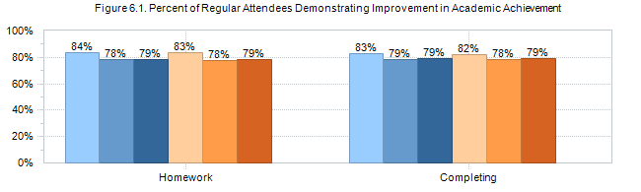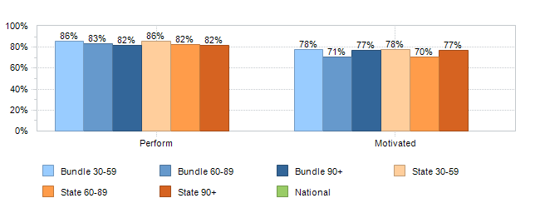

Key to Academic Achievement
Homework | Behavior change in terms of turning in homework on time
Completing | Behavior change in terms of completing homework to teacher’s satisfaction
Perform | Behavior change in terms of academic performance
Motivated | Behavior change in terms of coming to class motivated to learn

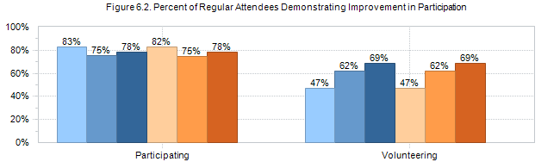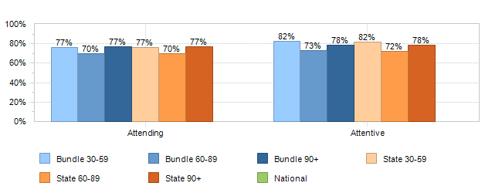

Key to Participation
Participating | Behavior change in terms of participating in class
Volunteering | Behavior change in terms of volunteering in class
Attending | Behavior change in terms of attending class regularly
Attentive | Behavior change in terms of being attentive in class
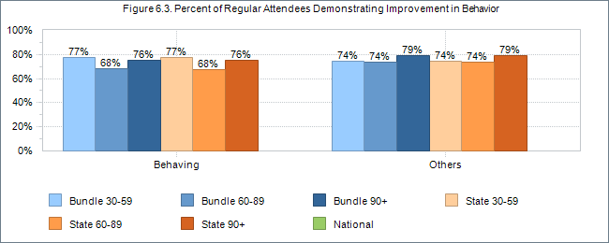
Key to Behavior
Behaving | Behavior change in terms of behaving in class
Others | Behavior change in terms of getting along well with others

Grantee and Sites in the Bundle that reported data for the 2009–10 APR reporting period:
Alamo Navajo School - Cohort 2: Alamo Navajo Community School
American Horse School: American Horse School
Baca Community School - Cohort 2: Baca/Dlo ay azhi Community School
Beatrice Rafferty Elementary School: Beatrice Rafferty Elementary School
Beatrice Rafferty High School: Shead High School
Bogue Chitto Elementary School: Bogue Chitto Elementary School
Chemawa Indian School: Chemawa Indian School
Chief Leschi School: Chief Leschi School
Chinle Boarding School, Inc.: Chinle Boarding School
Choctaw Central Middle School: Choctaw Central Middle School
Cibecue Community School: Cibecue Community School
Conehatta Elementary School: Conehatta Elementary School
Cottonwood Day School: Cottonwood Day School
Dibe Yazhi Hablti''n O''lt''s, Inc.: Dibe Yazhi Habitiin Olta', Inc
Dzilth-Na-O-Dilth-Hle Cohort 2: Dzilth-Na-O-Dith-Hle Community Grant School
Hannahville Indian School - Cohort 2: Hannahville Youth Center
Hunter's Point Boarding School: Hunters Point Boarding School
Indian Island School - Cohort 2: Indian Island Elementary School
Indian Township School: Indian Township Elementary School
Isleta Elementary School: Isleta Elementary School
Jeehdeez'a Academy Inc.: Jeehdeez'a Academy, Inc.
Kayenta Community School - Cohort 2: Kayenta Community School
Keam's Canyon Elementary School: Keam's Canyon Elementary School
Kin Dah Lich'i Olta School: Kin Dah Lichi'i Olta, Inc.
Kinlani Dormitory (Flagstaff): Flagstaff Dorm 21st Century After - School Program
Lac Courte Oreilles Ojebwa School: Lac Courte Oreilles Ojibwe School
Laguna Elementary: Laguna Elementary School
Little Wound School - Cohort 2: Little Wound Elementary School Wolakota K - 5th
Loneman School - Cohort 2: Loneman School
Lukachukai Community School - Cohort 2: Lukachukai Community School
Many Farms High School: Many Farms High School 21st CCLC
Meskwaki Elementary School - Cohort 2: Meskwaki Settlement School
Meskwaki High School: Meskwaki Settlement School
Nazlini Community School: nazlini community school campus
Northern Cheyenne Tribal School: Northern Cheyenne Tribal School
Ojibwa Indian School: Ojibwa Indian School
Pearl River Elementary School: Pearl River Elementary School
Pierre Indian Learning Center - Cohort 2: Pierre Indian Learning Center
Pine Ridge School: Pine Ridge school
Pyramid Lake High School: Pyramid Lake JR/SR High School 21st Century Community Learning Center
Red Water Elementary School: Red Water Elementary School
Riverside Indian School: Riverside Indian School Program
Salt River Elementary School: Salt River Elementary School
San Felipe Pueblo Elementary School: San Felipe Pueblo Elementary School
San Ildelfonso Day School: San Ildefonso Day School 21st Century After-School Program
San Simon School: San Simon School
Santa Fe Indian School: Santa Fe Indian School
Santa Rosa Boarding School - Cohort 2: Santa Rosa Boarding School
Seba Dalkai Boarding School- Cohort 2: Seba Dalkai Boarding School
Shonto Preparatory School - Cohort 2: Shonto Preparatory School
Shoshone-Bannock Jr./Sr. High School - Cohort 2: Shoshone-Bannock Jr./Sr. High School
Sky City Community School - Cohort 2: Sky City Community School
St. Stephen''s Indian School - Cohort 2: St.Stephen's Indian School
Standing Pine Elementary School: Standing Pine Elementary School
Takini School: Takini School
Taos Day School - Cohort 2: Taos Day School 21st Century Out-of-School-Time Programs
Theodore Jamerson - Cohort 2: Theodore Jamerson
Tiospaye Topa School: Tiospaye Topa School
Tohaali Community School: Tohaali Community School
Tohono O'odham High School: Tohono O' Odham HIgh School20
T'siya Day School: T'siya Day School
Tuba City Boarding School - Cohort 2: Tuba City Boarding School
Tucker Elementary School: Tucker Elementary School

GPRA Summary
In accordance with the Government Performance and Results Act (GPRA) of 1993, the US Department of Education has identified a series of indicators for the 21st CCLC program. This report summarizes the status of these GPRA indicators and provides state and national comparisons.
Bundle: Complete BIE
Objective 1: Participants in 21st Century Community Learning Center programs will demonstrate educational and social benefits and exhibit positive behavioral changes.
Performance Measures | 2009–2010
 | Bundle | State
1.1 The percentage of elementary 21st Century regular program participants whose mathematics grades improved from fall to spring. | 38.05% | 38.05%
1.2 The percentage of middle or high school 21st Century regular program participants whose mathematics grades improved from fall to spring. | 46.86% | 46.86%
1.3 The percentage of all 21st Century regular program participants whose mathematics grades improved from fall to spring. | 42.47% | 42.31%
1.4 The percentage of elementary 21st Century regular program participants whose English grades improved from fall to spring. | 45.48% | 45.48%
1.5 The percentage of middle or high school 21st Century regular program participants whose English grades improved from fall to spring. | 40.74% | 40.74%
1.6 The percentage of all 21st Century regular program participants whose English grades improved from fall to spring. | 42.71% | 42.59%
1.7 The percentage of elementary 21st Century regular program participants who improve from not proficient to proficient or above in reading on state assessments. | 20.17% | 20.17%
1.8 The percentage of middle/high school 21st Century regular program participants who improve from not proficient to proficient or above in mathematics on state assessments. | 12.03% | 12.03%
1.9 The percentage of elementary 21st Century regular program participants with teacher-reported improvement in homework completion and class participation. | 79.28% | 79.28%
1.10 The percentage of middle and high school 21st Century regular program participants with teacher-reported improvement in homework completion and class participation. | 68.48% | 68.48%
1.11 The percentage of all 21st Century regular program participants with teacher-reported improvement in homework completion and class participation. | 80.13% | 79.92%
1.12 The percentage of elementary 21st Century regular program participants with teacher-reported improvements in student behavior. | 77.19% | 77.19%
1.13 The percentage of middle and high school 21st Century regular program participants with teacher-reported improvements in student behavior. | 64.03% | 64.03%
1.14 The percentage of all 21st Century regular program participants with teacher-reported improvements in student behavior. | 76.44% | 76.27%
The data in the above charts demonstrate that the academic program emphasis is much stronger in homework help and classroom academics than core areas of measured proficiency.
Objective 2: 21st CCLC will offer high-quality enrichment opportunities that positively affect student outcomes such as school attendance and academic performance, and result in decreased disciplinary actions or other adverse behaviors.
Performance Measures | 2009–2010
 | Bundle | State
2.1 The percentage of 21st Century Centers reporting emphasis in at least one core academic area. | 87.3% | 87.69%
2.2 The percentage of 21st Century Centers offering enrichment and support activities in other areas. | 88.89% | 89.23%

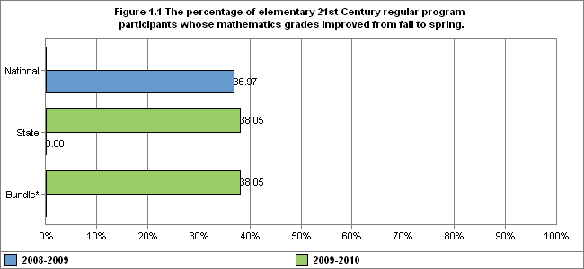
Of this Bundle's 63 center(s), 13 center(s) reported data for the 2009–2010 APR year.
Of this Bundle's 63 center(s), 0 center(s) reported data for the 2008–2009 APR year.
*The Bundle did not report this data for the 2008–2009 APR reporting period.
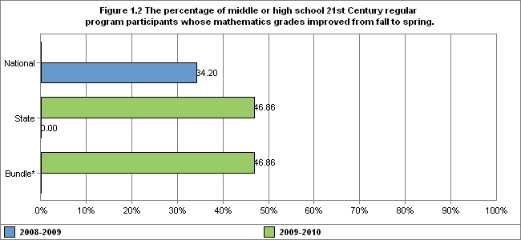
Of this Bundle's 63 center(s), 8 center(s) reported data for the 2009–2010 APR year.
Of this Bundle's 63 center(s), 0 center(s) reported data for the 2008–2009 APR year.
*The Bundle did not report this data for the 2008–2009 APR reporting period.
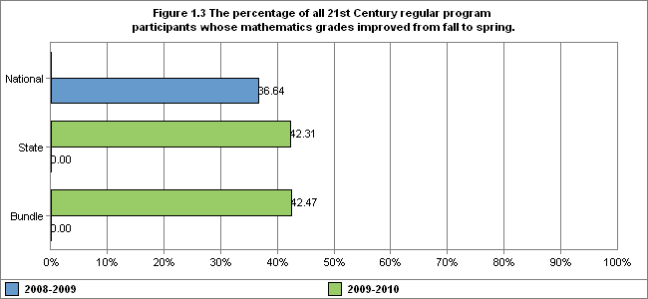
Of this Bundle's 63 center(s), 63 center(s) reported data for the 2009–2010 APR year.
Of this Bundle's 63 center(s), 0 center(s) reported data for the 2008–2009 APR year.
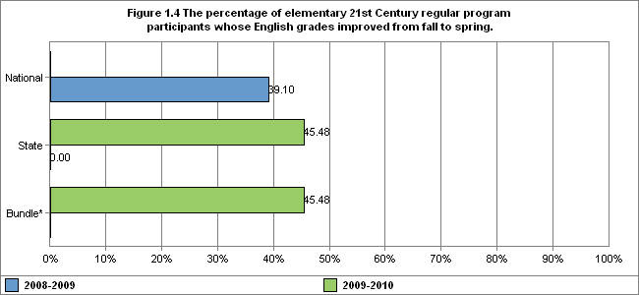
Of this Bundle's 63 center(s), 13 center(s) reported data for the 2009–2010 APR year.
Of this Bundle's 63 center(s), 0 center(s) reported data for the 2008–2009 APR year.
*The Bundle did not report this data for the 2008–2009 APR reporting period.
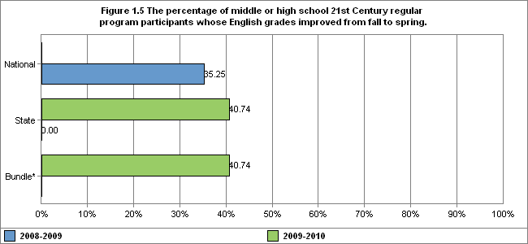
Of this Bundle's 63 center(s), 8 center(s) reported data for the 2009–2010 APR year.
Of this Bundle's 63 center(s), 0 center(s) reported data for the 2008–2009 APR year.
*The Bundle did not report this data for the 2008–2009 APR reporting period.
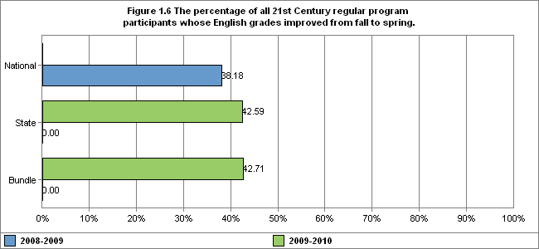
Of this Bundle's 63 center(s), 63 center(s) reported data for the 2009–2010 APR year.
Of this Bundle's 63 center(s), 0 center(s) reported data for the 2008–2009 APR year.
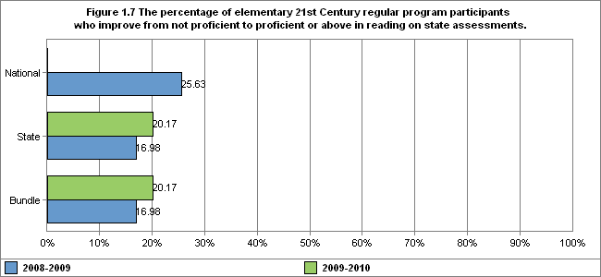
Of this Bundle's 63 center(s), 13 center(s) reported data for the 2009–2010 APR year.
Of this Bundle's 63 center(s), 15 center(s) reported data for the 2008–2009 APR year.
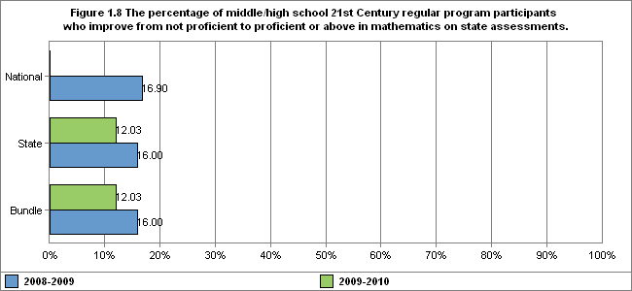
Of this Bundle's 63 center(s), 8 center(s) reported data for the 2009–2010 APR year.
Of this Bundle's 63 center(s), 7 center(s) reported data for the 2008–2009 APR year.
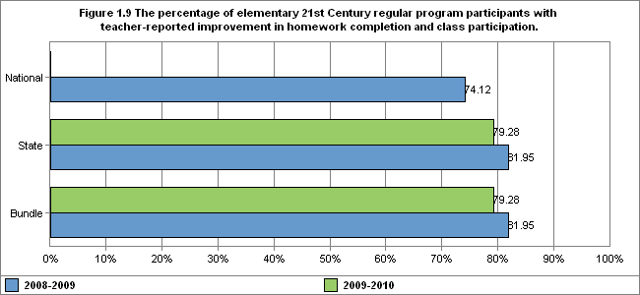
Of this Bundle's 63 center(s), 13 center(s) reported data for the 2009–2010 APR year.
Of this Bundle's 63 center(s), 15 center(s) reported data for the 2008–2009 APR year.
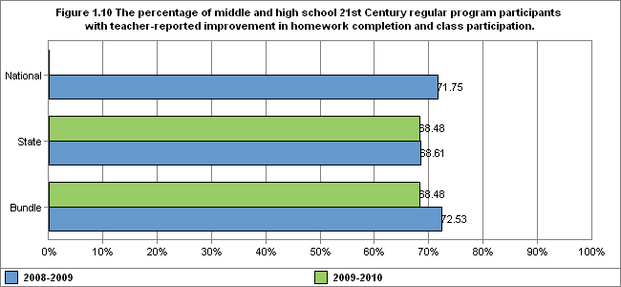
Of this Bundle's 63 center(s), 8 center(s) reported data for the 2009–2010 APR year.
Of this Bundle's 63 center(s), 7 center(s) reported data for the 2008–2009 APR year.
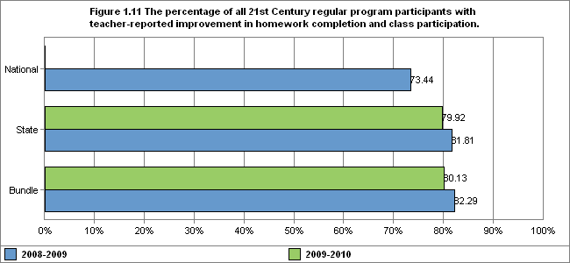
Of this Bundle's 63 center(s), 63 center(s) reported data for the 2009–2010 APR year.
Of this Bundle's 63 center(s), 57 center(s) reported data for the 2008–2009 APR year.
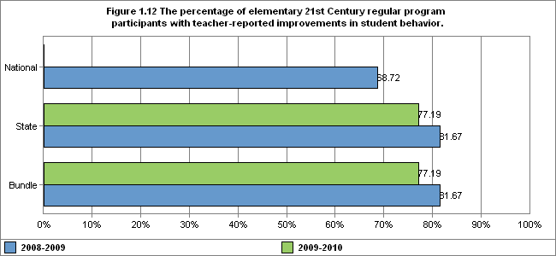
Of this Bundle's 63 center(s), 13 center(s) reported data for the 2009–2010 APR year.
Of this Bundle's 63 center(s), 15 center(s) reported data for the 2008–2009 APR year.
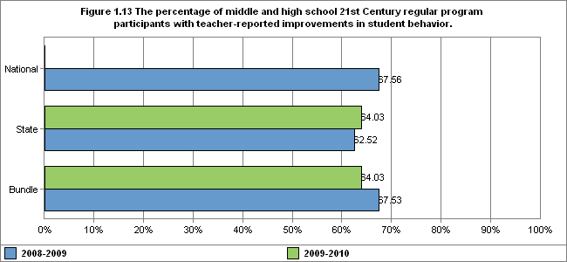
Of this Bundle's 63 center(s), 8 center(s) reported data for the 2009–2010 APR year.
Of this Bundle's 63 center(s), 7 center(s) reported data for the 2008–2009 APR year.
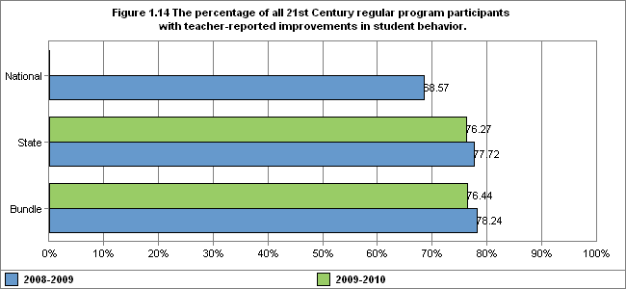
Of this Bundle's 63 center(s), 63 center(s) reported data for the 2009–2010 APR year.
Of this Bundle's 63 center(s), 57 center(s) reported data for the 2008–2009 APR year.
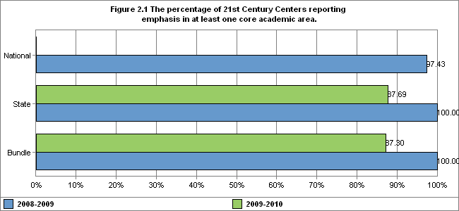
Of this Bundle's 63 center(s), 63 center(s) reported data for the 2009–2010 APR year.
Of this Bundle's 63 center(s), 57 center(s) reported data for the 2008–2009 APR year.
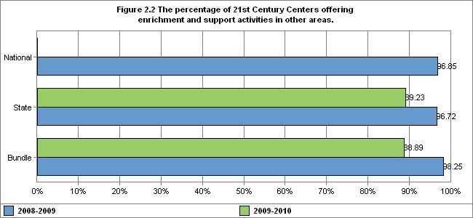
Results of visits during 2010-11 program year using the benchmarking tool:

This tool was developed for the purpose of an indication of current program status following a review of the above PPICS data for all 64 locations. The intent of the instrument and resulting data is intended to be used to guide program improvement and areas of strength. The data covers the following areas:
- Performance objectives
- Programming
- Academics
- Enrichment
- Family
- Operations
- Morale

Information to complete the scale was taken from a review of all PPICS data entered by program directors for 2009-10 program year, interviews with program staff & administration, and program observation of 64 or 100% of operational programs.

As based on the data in the chart above, it is apparent that the areas of improvement across the BIE include what is currently being done academically and with family programming. Each of the programs that scored relatively low were provided with ideas and opportunities designed and delivered to improve areas within the academic and family programming. Ongoing training will be necessary in the area of academics before wide-spread change will occur. The academic ideas are coordinated with that which is happening in the regular school day program.

Instrument used:
What is/are the academic focus (s) of this program?
What is/are the non-academic focus (s) of this program?
How do you achieve the family component?
Please answer each of the following questions to the best of your ability at this time using the following scale: (generally inferred from available data)
5 = Strongly Agree or Absolutely
4 = Agree or Occasionally
3 = Neutral
2 = Disagree or Seldom
1 = Strongly Disagree or Never

- Performance Objectives
  - Our performance objectives are aligned to the identified needs in the needs assessment.
  - Our performance objectives are relevant.
  - Our objectives are measured objectively.
  - Our objectives are aligned to the state goals/objectives.
- Programming
  - Our programming (courses or activities offered) meets the state minimum guidelines for
  - Our programming addresses the stated objectives.
  - Our programming reflects our stated emphasis.
  - Our programming meets or exceeds the desired attendance results.
- Academics
  - Each student enrolled in a course in our program has an individual academic performance goal.
  - Academic programming provided is aligned to the identified needs of students?
  - There is a strong correlation between the programming provided and the measures of academic progress used.
  - Staff members know how to understand the academic needs of students and how to address those needs.
  - Student participation is frequent enough to meet the academic goal set for that student.
- Enrichment
  - Programming is built to attract and retain children.
  - Enrichment programming is supported in the grant.
  - Our enrichment activities are the ones students want to have.
- Family
  - Family programming is offered frequently enough for consistent participants to build relationships with the school.
  - There is evidence that family programming offered is of value to the families of our program participants.
  - The intent or purpose of family programming is met through what we offer families.
  - Family programming aligns to one or more objective.
- Morale
  - There is evidence that the teachers and administrators of the school support the OST program.
  - Staff are enthusiastic and moral is high in the OST program.
- Operations
  - Staff members are hired through an established process either through the school or 21st CCLC written process.
  - Staff are prepared for the duties required of them in the 21st CCLC programs.
  - OST facilities are safe, well kept and adequate to meet the ongoing needs of the OST program.
  - There is a policy manual that governs the operations of the OST program.
  - The budget is well kept and monitored sufficiently to ensure wise use of funds.

Based on the findings of the benchmarking instrument used during the 2010-11 site visits, the following findings and recommendations exist:
- The operational efficiencies and compliance are monitored and followed across the BIE. Program directors are diligent about following the proper protocols to insure student safety and security. Directors are also concerned about what they are “required” to do.
- The majority of staff members and programs appear to enjoy the work that they do in the OST program. Do to the limitation of available personnel, most programs are staffed by regular school day personnel. Though the days are long for staff, most appear to effectively engage the students in their care. Staff members that I observed and especially those I visited with really do seem to care for the children they serve.
- Most locations offer programming to accomplish the academic and enrichment elements of 21st CCLC. Very few programs are academic only and no programs offer only enrichment activities. Programs may benefit from an understanding of the concept that programming is the singular most important component of attendance. With programming that continually holds the interest of students, attendance will take care of itself. Given the past attendance patterns noted in prior years within PPICS, this concept is not well understood.
- Enrichment is offered in most locations with the purpose to provide programming that will comply with the federal and BIE goal. Many programs would benefit from the understanding that the key to regular attendance is programming and the enrichment parts of the program are the most pivotal to the attendance rates.
- All programs have measureable objectives. Most performance objectives are not reflective of the programming offered. As the objectives set the direction of the program as a whole, most programs would benefit from an examination of the objectives in light of what is actually done in the program and the desired outcomes of the program.
- While each program has some form of programming that addresses the academic component of 21st CCLC, most are not closely associated with the academic needs of the individual students who attend. The programs of the BIE would benefit from an understanding of the individual academic needs of the students they serve and strive to support those needs through programming.
- Many of the BIE 21st CCLC programs offer little or no family programming. The family and in particular the parent connection is vital to the overall success of the children. The BIE programs would benefit from understanding the overall connection of the home/family relationship and how 21st CCLC can benefit that process. There are a few programs who offer frequent wonderful opportunities for family involvement.

Recommendations:
- Adopt a clear continual evaluation process that focuses on effectiveness in relation to academic growth, attendance and family relationships
- Offer training through the year with the intent of enhancing both the understanding and practice of attendance and academic student growth
- Offer training that would increase program directors understanding of the critical home/school relationship and how to effectively nurture that relationship through the program
- Continue the on-site visits with an increased level of pre-conference participation from the program director and school administrator so that the focus of the visit can be more particular to the needs of the location

